PEDRO PAN: A NEW CHILDREN’S MUSICAL
Posted On 08 Aug 2015 / 0 Comment

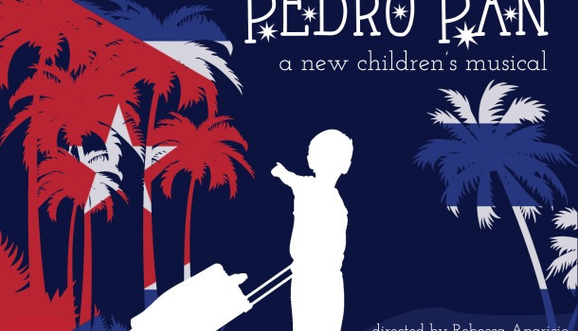
0 COMMENT
Operación Pedro Pan was a migration of unaccompanied children from Cuba during the 1960’s when Cuban parents feared indoctrination and the Cuban government taking away their parental authority.
Pedro Pan is a new bi-lingual children’s musical exploring the struggles of Pedro, a young boy sent to the US by his parents to escape the growing dangers of revolutionary Havana. Once in the United States, Pedro learns to adapt to a new language, culture, and country.
However, Pedro quickly faces discrimination as an immigrant and meets Roger, a young boy from Mexico, who teaches Pedro how to assimilate and “become an American.” Together they form the “Lost Boys Club” to hide their cultural heritage, and meet Wendy, a young Black girl from Alabama, who teaches them to embrace their differences despite the discrimination they will continue to face.
“Although the story takes place in 1962, the themes of cultural acceptance and race relations remain heated topics in 2015,” says writer/director Rebecca Aparicio. “We have all experienced being the new kid or dealing with the sense of a lost identity. As the daughter of two Cuban exiles, I can identify with children immigrating today and the discrimination they face. My hope is that children can identify with Pedro and find comfort knowing they are not alone in their journey.”
The show needs additional funding, however. About $3,000 is still needed to cover production costs. You can learn more about contributing here. Support can also be given by purchasing a ticket or spreading the word on social media.
Pedro Pan opened in Long Island City at The Chain Theatre in February 2014, and will run from August 16-28 at the 14th Street YMCA in New York as part of the International Fringe Festival.

Highlights from PEDRO PAN, a new children's musical

<div class="player-unavailable"><h1 class="message">An error occurred.</h1><div class="submessage"><a href="http://www.youtube.com/watch?v=4j_BNDU6dX4">Try watching this video on www.youtube.com</a>, or enable JavaScript if it is disabled in your browser.</div></div>

Tags: pedro pan

End each blog post
AddThis Smart Layers BEGIN Go to http://www.addthis.com/get/smart-layers to customize AddThis Smart Layers END
DEBRA FREEMAN
Marketing maven by day. Writer for thecheekymusic.wordpress.com and assorted websites by night.

